

|  |
| --- |
| **Department of Institutional Research and Assessment**  **Alumni Survey Analysis Class of 2016-2017**  **3/1/2019**  **Your suggestions and comments are welcomed. For questions or additional queries do not hesitate to contact us by email : dira@lau.edu.lb or at extensions 1232, 1783, 1659** |

**TABLE OF CONTENTS**

EXECUTIVE SUMMARY v

METHODOLOGY 7

Demographic Characteristics of Respondents 7

MAJOR FINDINGS 10

Employment and Post-graduation status 10

i. Current Employment Status 10

ii. Continuing Education 11

iii. Time to first job 12

iv. Job search methods 15

First Job Experience 17

i. Type 17

ii. Correlation of Job to Undergraduate Field of Study 18

iii. Location 20

iv. Industry 25

v. Starting Basic Salary 25

vi. Other Company Characteristics 32

University Experience & Skills Acquired 33

i. Internship Experience 33

ii. Satisfaction with University Experience 34

iii. Job Preparation 36

iv. Skills acquired 39

**LIST OF TABLES**

Table 1 Respondents by Degree Program 9

**LIST OF FIGURES**

Figure 1 Respondents by Gender 8

Figure 2 Respondents by Term of Graduation 8

Figure 3 Respondents by School 8

Figure 4 Employment Status 10

Figure 5 Alumni Continuing higher education based on Undergraduate Degree 11

Figure 6 Employment Rates Based on Time to Initial Employment 12

Figure 7 Employment Rates by Degree Prior to Graduation 13

Figure 8 Employment Rates by Degree Twelve Months After Graduation 14

Figure 9 Methods Alumni relied on for their job search 15

Figure 10 Alumni who relied on LAU Job Search Platforms and Services based on Degree 16

Figure 11 Job Type by Gender 17

Figure 12 Employment in Jobs Related to Undergraduate Field of Study by Semester of Graduation 18

Figure 13 Employment in Jobs Related to Undergraduate Field of Study by Undergraduate Degree 19

Figure 14 Employment by Job Location 20

Figure 15 Geographical Preference of First Job Location by Region 21

Figure 16 Geographical preference of first job location by region (summary) 21

Figure 17 Employment Rates by School and Location 22

Figure 18 Alumni Employed Abroad by Degree 23

Figure 19 Employment by governorate 24

Figure 20 Trends in Employment By Governorate 24

Figure 21 Employment by company industry 25

Figure 22 Average Starting Basic Salary by Gender 26

Figure 23 Starting Basic Salary Brackets by Gender 27

Figure 24 Average Starting Basic Salary by Region 28

Figure 25 Average Starting Basic Salary by Degree 29

Figure 26 Average Starting Basic Salary by Industry 30

Figure 27 Average Starting Basic Salary with respect to Time from Graduation 31

Figure 28 Company Type 32

Figure 29 Company classification 32

Figure 30 Alumni who were Offered a Full-Time Job After Completion of Internship by Degree 33

Figure 31 University choice of alumni were they to start again 34

Figure 32 alumni expression an interest to pursue same degree at lau should they start again by degree 35

Figure 33 Alumni who Believed they were Sufficiently Prepared to Obtain First Job by Gender 36

Figure 34 Alumni who Believed they were Sufficiently Prepared to Obtain First Job by Degree 37

Figure 35 Comparison of Job Preparation Received by LAU Alumni to Other Graduates 38

Figure 36 LAU’s contribution to acquisition of skills by alumni 39

ACRONYMS

AKSOB Adnan Kassar School of Business

ARCSON Alice Ramez Chagoury School of Nursing

SArD School of Architecture and Design

SAS School of Arts and Sciences

SOE School of Engineering

SOP School of Pharmacy

LAU Lebanese American University

# EXECUTIVE SUMMARY

The key findings based on responses of the graduates of 2016-2017 are summarized below. Findings can be used to predict with 95% confidence the true population statistic within +/- 3 percentage points of the sample statistic.

* 95% of LAU graduates were employed within 12 months of graduation.
* Graduates majoring in Chemistry, Electrical Engineering, Multimedia Journalism, English, Fashion Design, Education, Nursing, Graphic Design, Business (Hospitality Management), Business (Family & Entrepreneurial Management), Social Work, Education, Mathematics, Nutrition, Nutrition and Dietetics Coordination Program, Computer Science, Biology, Industrial Engineering, Computer Engineering, Political Science and International Affairs, Interior Architecture and Communication Arts had a 100% chance of securing a job.
* To search for their first job, graduates across all majors mainly relied on online job search platforms (74%), followed by family or personal connections (61%), social media platforms (47%), LAU career guidance/career portal (39%), LAU career fair (35%), career fairs organized by other organizations (15%), LAU academic departments (11%), an LAU teacher/faculty (10%), online newspapers (7%), and 4% on print newspapers.
* 27% graduates sought or earned a graduate/doctoral degree.
* Around 80% of graduates confirmed that their first job was related to their undergraduate field of study. This percentage has improved from 76% when comparing to 2015-2016 graduates.
* The vast majority of respondents found their first job in Lebanon (91%) whereas 5% found their first job in the gulf region, 1% in North America, 1% in the Levant and 1% in Africa To a large extent, the actual distribution of first job location is similar to the initial geographical preference of respondents.
* External employers had a demand for graduates who majored in Business (Banking & Finance, Marketing), Architecture, Communication Arts, Economics, and Engineering (Civil, Computer, and Electrical).
* Graduates who were employed in Lebanon were mostly based inside the capital Beirut. There has been however a decrease in LAU graduates employed in Beirut in the last few years from 79% in 2014-2013 to 75% in 2015-2016 to 73% in 2016-2017 which reflects a spread of employment opportunities across the country especially in the governorate of Mount Lebanon.
* The industries that employed most of LAU graduates were (1) Architecture & Construction, (2) Non-Governmental Organization, (3) Sales & Distribution of Consumer Products, (4) Health Science/Medical, (5) Finance/Banking and (6) Education & Training.
* The average starting basic salary for all graduates amounted to $1,153. The average basic salary ranged from $1,113 for graduates employed in Lebanon to $1598 for those employed in the Gulf. The highest paid graduates were those employed in North America and Africa.
* The highest paid majors were: Multimedia Journalism, Fashion Design, Pharmacy, Engineering (Mechanical, Computer, Industrial, Electrical, and Civil), Business (Family and Entrepreneurial Business Management, Marketing, International Business), and Architecture.
* 25% of graduates who had an internship experience were offered a full-time job afterwards in the same company. Graduates who majored in Fashion Design, Biology, Hospitality & Tourism Management and Industrial Engineering were in the majority offered a full-time job after completing their internship.
* Were they to start again, 91% of graduates would pursue their studies at LAU.
* 94% of graduates believed that the preparation they received is the same or better than that received by their peers from other universities.
* 63% or more of alumni believed that their LAU education had a significant contribution (either “major” or “significant”) to their acquisition of the following: (1) functioning as a team member, (2) ability to think critically and approach new problems with an open and analytical mind (3) developing oral communication skills, (4) developing written communication skills and (5) instilling commitment for life-long learning.

# METHODOLOGY

All LAU alumni of the academic 2016-2017 were invited to participate in the online alumni survey. Alumni who did not complete their undergraduate studies at LAU were not invited. The alumni survey aimed at determining the employment and educational status of graduates and their views on the added value of internships on employment, when applicable. Alumni perspectives on their level of preparedness for employment reflected in the possession of the required theoretical knowledge and essential soft skill sets were also investigated.

The survey was disseminated by email to 1,622 LAU alumni. Targeted Facebook advertisements were also used to enhance response rate. To ensure that only LAU graduates of the specified years completed the survey through the Facebook public link, respondents were required to provide their LAU username and password before they could access the survey. This method also guaranteed that alumni could respond to the survey only once. In addition, the survey was conducted over phone calls in order to increase the responses.

Out of the 1,622 alumni invited, 634 responded yielding a response rate of 39%. The generalizability of the results to the population depends on the sample size, which in turn depends on the degree of precision desired, the variability of the data sampled, and the type of sampling employed, namely level of tolerated error accepted. With 634 respondents, a 3 percent margin of error and a 95 percent confidence interval were generated. As such one can predict with 95% confidence that the true population statistic is within +/- 3 percentage points of the sample statistic.

## Demographic Characteristics of Respondents

Out of the 634 respondents, 56% were females (Figure 1). The highest proportion of respondents (75%) were graduates of Spring 2017 term, followed by 25% of Fall 2016 and 1 respondent of Summer 2017. (Figure 2). Most respondents were graduates from the AKSOB (40%), while 29% were graduates from the SAS, 14% from the SOE, 11% from the SArD, 4% from the SOP, and 2% from the ARCSON (Figure 3). These percentages mirror to a large extent graduation patterns at LAU by school. As for the majors of respondents, 12% majored in Banking and Finance, 8% in Marketing and Biology, 6% in Management Studies and Civil Engineering, 4% in Mechanical Engineering, Communication Arts, Economics, International Business, Nutrition, Pharmacy and Architecture, and 3% in Psychology. Alumni who majored in Accounting, Computer Engineering, Computer Science, Education, Graphic Design, Nursing, Political Science/International Affairs, Interior Design and other majors also participated in the survey. Table 1 gives the full distribution of respondents by degree program.

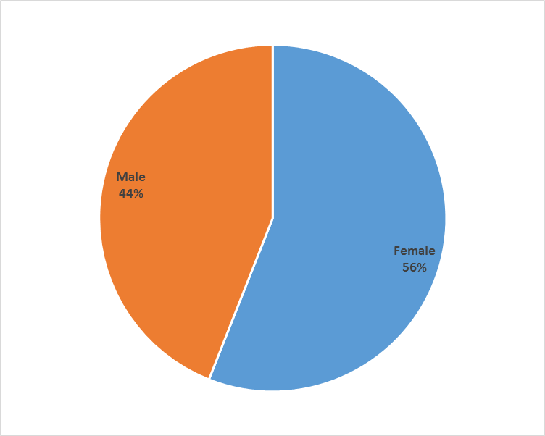

Figure 1 Respondents by Gender

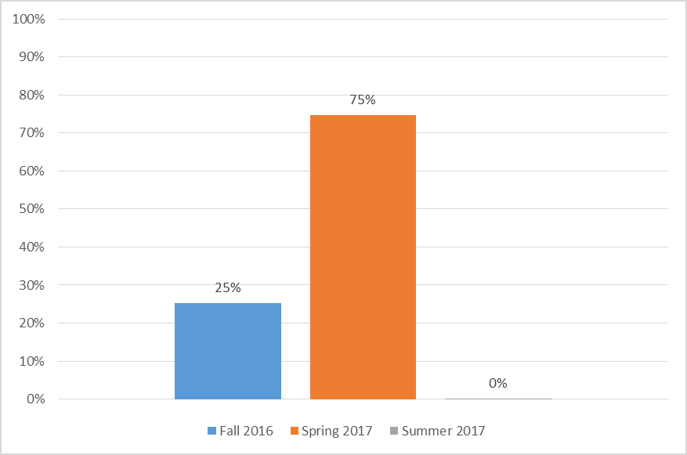

Figure 2 Respondents by Term of Graduation

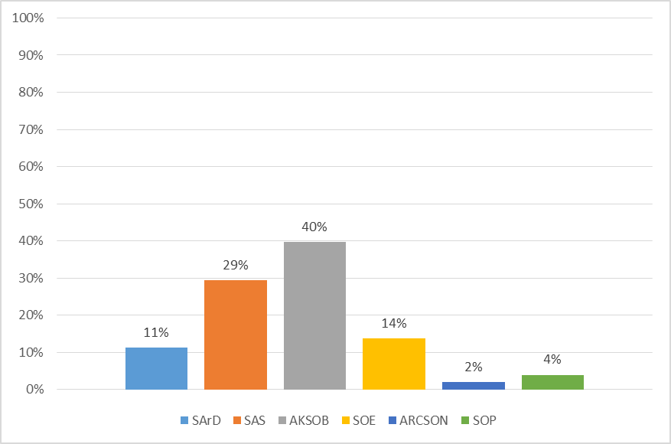

Figure 3 Respondents by School

Table 1 Respondents by Degree Program

|  |  |  |  |
| --- | --- | --- | --- |
| **Degree Program** | **Respondents** | **Percent of Total Respondents** | **Percent of Target Population** |
| BA in Multimedia Journalism | 2 | 0.32% | 66.67% |
| BS in Hospitality & Tourism Management | 8 | 1.26% | 53.33% |
| BS in Chemistry | 5 | 0.79% | 50.00% |
| BS in Business- International Business | 25 | 3.94% | 48.08% |
| BS in Business- Banking and Finance | 78 | 12.30% | 46.71% |
| BS in Graphic Design | 14 | 2.21% | 45.16% |
| BA in English | 4 | 0.63% | 44.44% |
| BE in Industrial Engineering | 7 | 1.10% | 43.75% |
| BE in Computer Engineering | 13 | 2.05% | 43.33% |
| BS in Business- Information Technology Management | 13 | 1.89% | 43.33% |
| BS in Nutrition | 26 | 4.10% | 43.33% |
| BA in Social Work | 3 | 0.47% | 42.86% |
| BE in Electrical Engineering | 8 | 1.26% | 42.11% |
| BS in Biology | 53 | 8.36% | 41.09% |
| BA in Education | 11 | 1.74% | 40.74% |
| BA in Psychology | 21 | 3.31% | 40.38% |
| BS in Pharmacy | 25 | 3.94% | 40.32% |
| Bachelor of Architecture | 28 | 4.42% | 40.00% |
| BS in Computer Science | 14 | 2.21% | 40.00% |
| BE in Civil Engineering | 35 | 5.52% | 39.77% |
| BA in Communication Arts | 24 | 3.79% | 39.34% |
| BS in Economics | 24 | 3.79% | 39.34% |
| BS in Interior Design | 14 | 2.21% | 38.89% |
| BE in Mechanical Engineering | 24 | 3.79% | 38.71% |
| BS in Nursing | 13 | 2.05% | 38.24% |
| BS in Business- Marketing | 48 | 7.57% | 38.10% |
| BS in Nutrition & Dietetics (Coordinated Program) | 3 | 0.47% | 37.50% |
| BS in Business-Accounting | 14 | 2.21% | 36.84% |
| BA in Political Science/International Affairs | 15 | 2.37% | 35.71% |
| BA in Fine Arts | 1 | 0.16% | 33.33% |
| BA in Translation | 1 | 0.16% | 33.33% |
| BA in Interior Architecture | 13 | 2.05% | 30.95% |
| BS in Business - Management | 41 | 6.47% | 30.15% |
| BS in Mathematics | 3 | 0.47% | 30.00% |
| BS in Bioinformatics | 1 | 0.16% | 25.00% |
| BS in Business - Family and Entrepreneurial Business Management | 1 | 0.16% | 16.67% |
| BA in Fashion Design | 1 | 0.16% | 7.69% |

# MAJOR FINDINGS

## Employment and Post-graduation status

### Current Employment Status

The current employment status of the LAU Alumni of AY 2016-2017 varies. 70% of the respondents reported to have been employed at least once since their graduation. Out of these, 61% are currently employed whereas 9% have been employed once. The remaining 30% have never been employed. In fact, 19% did not seek a job while 11% did not actually find one. (Figure 4).

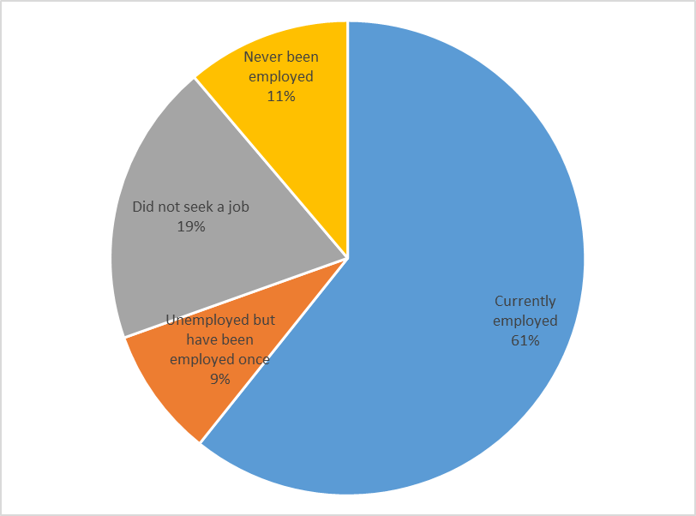

Figure 4 Employment Status

### Continuing Education

Alumni were asked about whether they had sought further education after they completed their undergraduate studies. 27% confirmed that they had already earned or are currently pursuing a graduate degree or a doctoral degree. In fact, out of the 39% who are currently unemployed – never been employed, did not seek a job and unemployed but at least employed once – 44% are full-time graduate or doctoral students. Alumni who opted to continue their education had mostly completed their undergraduate degree in Bioinformatics, Biology, Nutrition, Chemistry, Multimedia Journalism and Pharmacy (Figure 5).

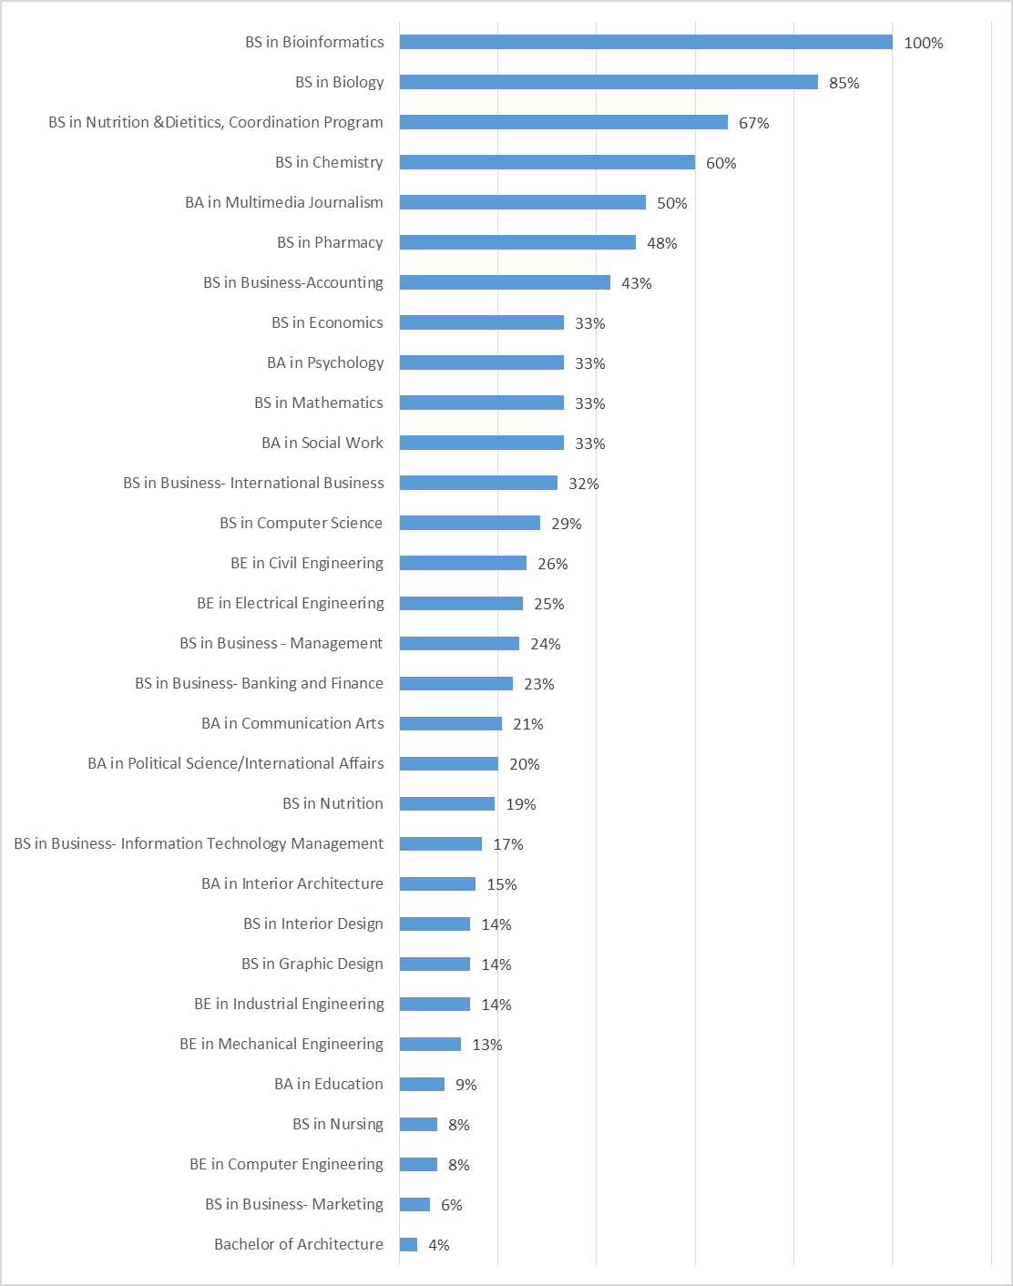

Figure 5 Alumni Continuing higher education based on Undergraduate Degree

### **Time to first job**

When asked about the time spent to find their initial job, 17% of alumni reported to have found their first job prior to graduation. Within the first six months after graduation, 79% had secured a job. This rate increased to 95% 12 months after graduation (Figure 6).

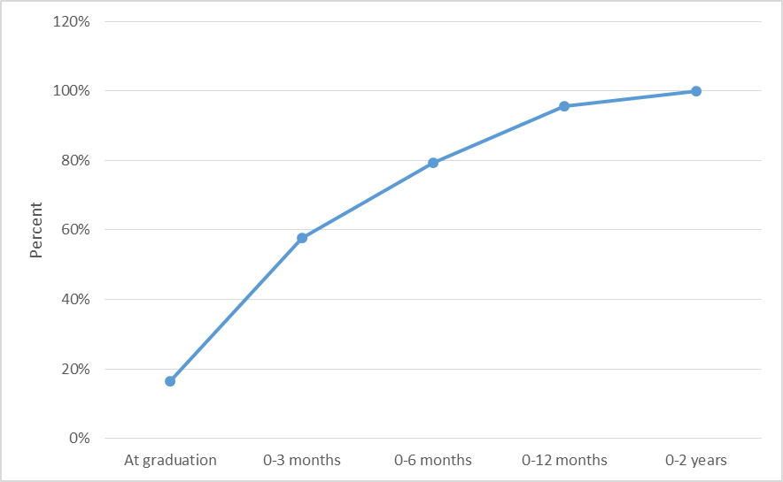

Figure 6 Employment Rates Based on Time to Initial Employment

Based on survey findings, 100% of alumni who majored in Fashion Design, Business (Family & entrepreneurial management), and Social Work were able to find a job prior to graduation. 20-50% of those who majored in Education, Mathematics, Chemistry, Computer Engineering, Computer Science, Communication Arts and Graphic Design reported finding a job prior to graduation. However only 5-10% of alumni who majored in Civil Engineering, Architecture, Nursing, Interior Architecture, Psychology and Business (Management) secured a job by graduation (Figure 7).

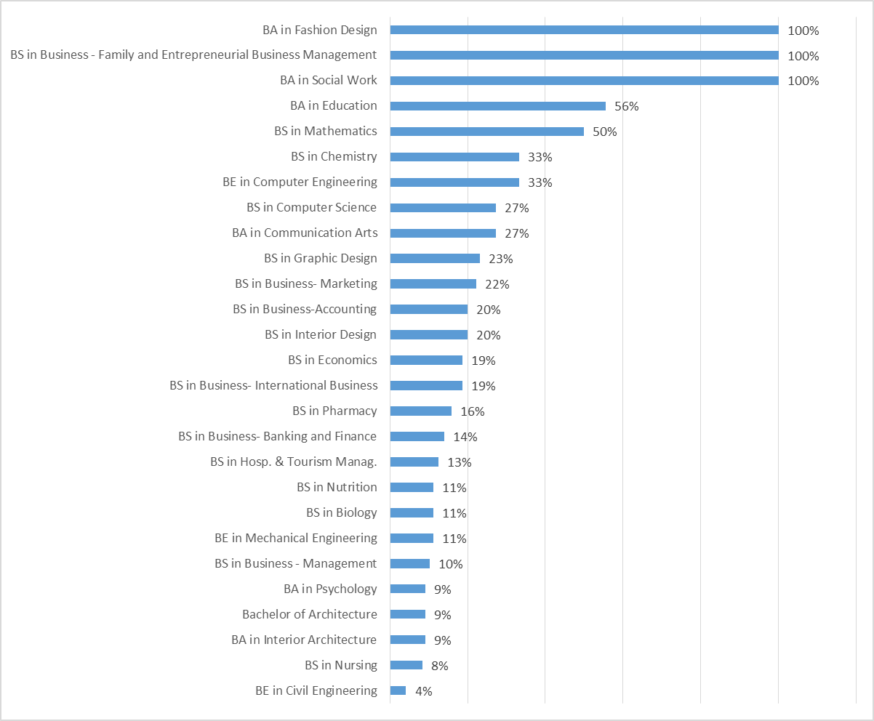

Figure 7 Employment Rates by Degree Prior to Graduation

For a period of up to twelve months after graduation, all alumni (100%) who majored in Chemistry, Electrical Engineering, Multimedia Journalism, English, Fashion Design, Education, Nursing, Graphic Design, Business (Hospitality Management), Business (Family & Entrepreneurial Management), Social Work, Education, Mathematics, Nutrition, Nutrition and Dietetics Coordination Program, Computer Science, Biology, Industrial Engineering, Computer Engineering, Political Science and International Affairs, Interior Architecture and Communication Arts were capable of securing a job. Over the same period, most alumni (95-80%) who majored in Business (Management), Business (Marketing), Pharmacy, Architecture, Mechanical Engineering, Business (Banking & Finance), Economics, Business (International Business), Psychology, Business (Information Technology Management), Interior Design, Business (Accounting) and Civil Engineering were able to find a job. (Figure 8).

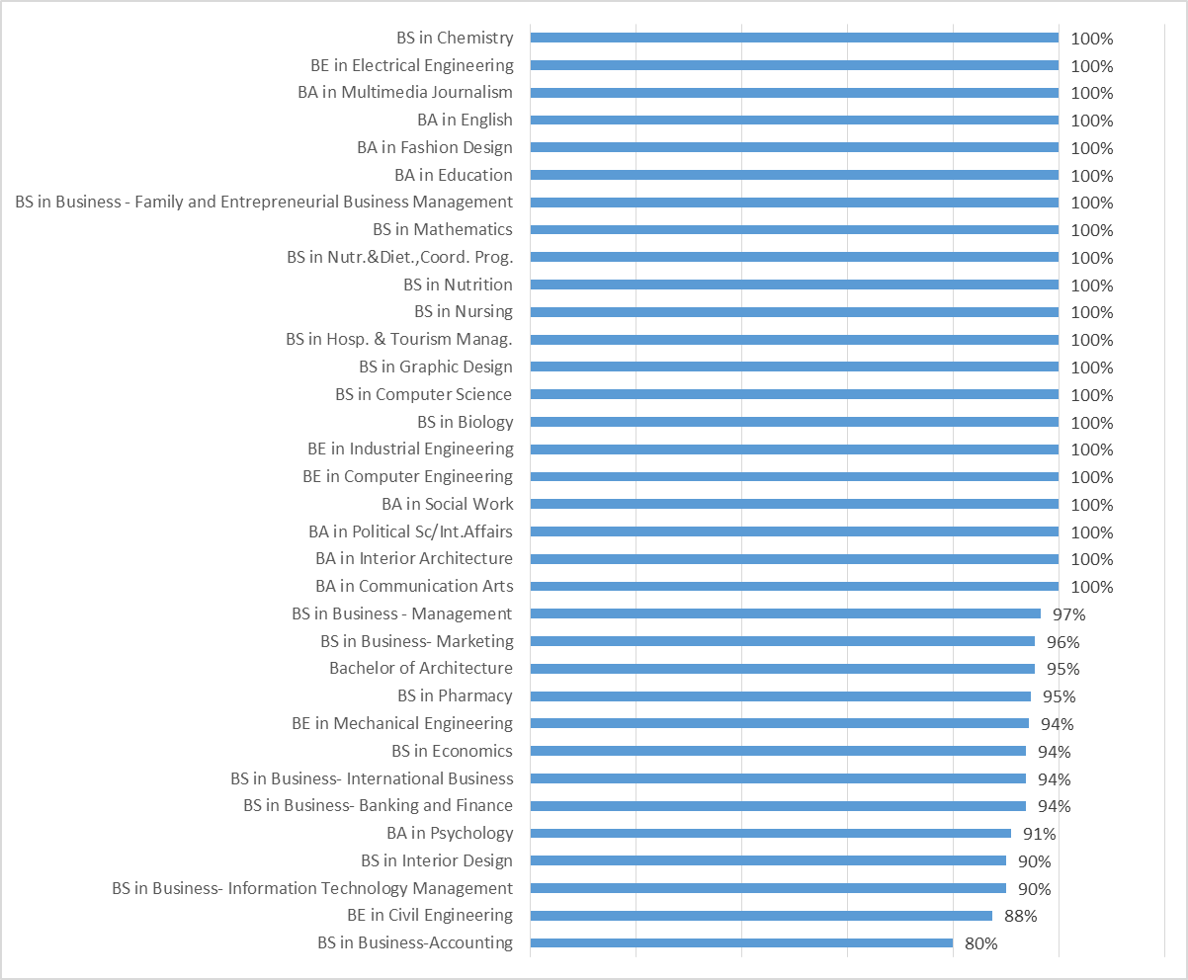

Figure 8 Employment Rates by Degree Twelve Months After Graduation

### Job search methods

Alumni reported using a variety of methods when searching for their first job. Alumni mainly relied on online job search platforms when attempting to search for their first job (74%), followed by family or personal connections (61%), social media platforms (47%), LAU career guidance/career portal (39%), LAU career fair (35%), career fairs organized by other organizations (15%), LAU academic departments (11%), an LAU teacher/faculty (10%), online newspapers (7%), and 4% on print newspapers (Figure 10).

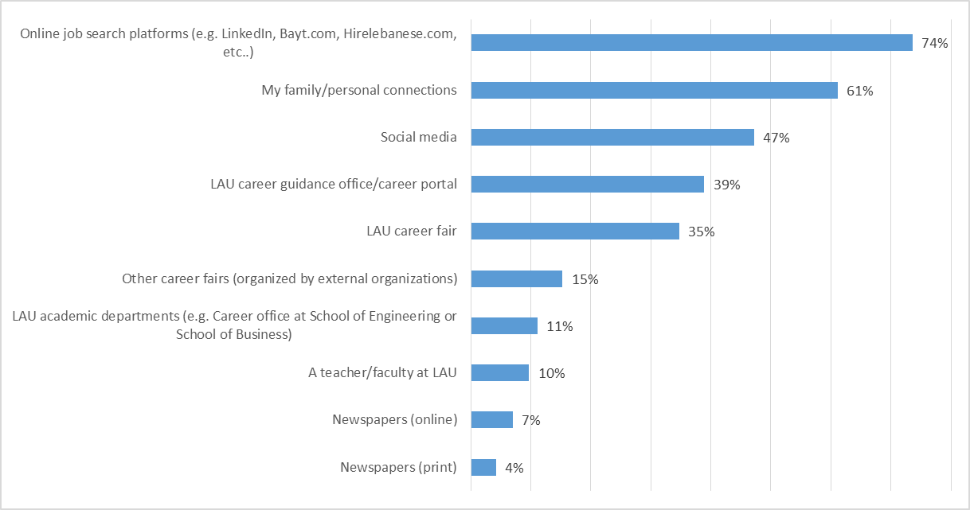

Figure 9 Methods Alumni relied on for their job search

Graduates across all majors have relied on LAU job search platforms and services - the career fair, career guidance office/career portal, academic departments, and faculty - to secure employment particularly those who majored in Information Technlogoy Management(100%), Accounting(100%), Hospitality and Tourism Management (100%), Graphic Design( 100%), Industrial Engineering (100%), Computer Engineering (100%), Interior Architecture (100%) Management (83%), Banking and Finance (71%), Mechanical Engineering (71%), Civil Engineering (71%), Nutrition (50%), Interior Design(50%), Architecture (50%) and Marketing (40%) (Figure 10). Less reliant on these platforms are graduates who majored in International Business (33%), Social Work (33%), Political Science and International Affairs(25%) and Communication Arts (17%).

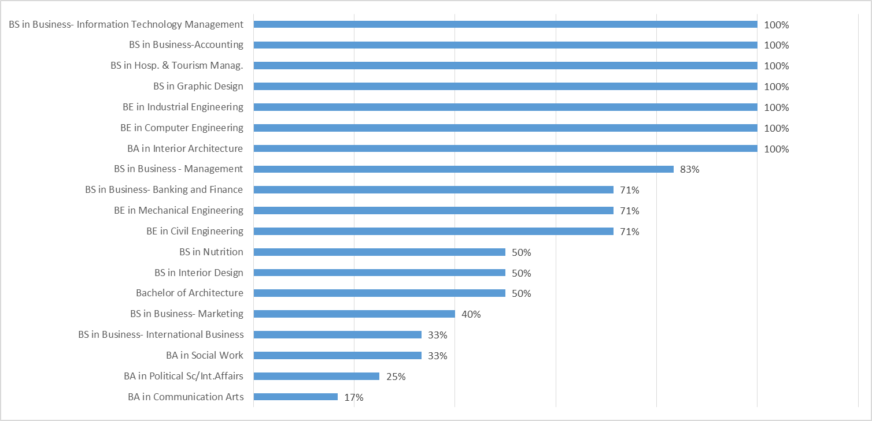

Figure 10 Alumni who relied on LAU Job Search Platforms and Services based on Degree

## First Job Experience

### Type

A vast majority of respondents (78%) reported that the first job they had secured was on a full-time basis whereas 15% reported that the job was on a part-time basis. While more males (84%) were likely to secure a full-time job than females (73%), the proportion of females (18%) securing part-time jobs was higher than males (12%) (Figure 11. In addition, 7% reported to have been self-employed and those mostly majored in Communication Arts, Civil Engineering, Graphic Design, Nutrition and Business.

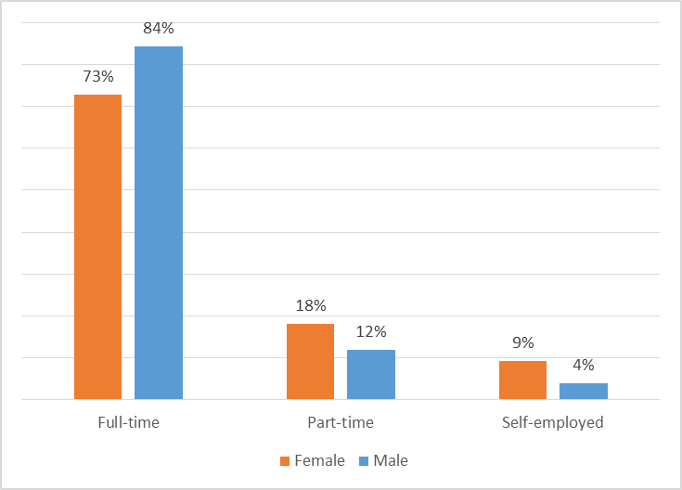

Figure 11 Job Type by Gender

### Correlation of Job to Undergraduate Field of Study

Not all respondents worked in their field of study. In fact, 80% of alumni confirmed that their first job was related to their undergraduate major. The correlation of job to undergraduate field of study doesn’t really vary by graduation cohorts. While 80% of alumni who graduated in Fall 2016 were employed in jobs related to their undergraduate field of study, this percentage increased only to 81% for those who graduated in the Spring 2017. (Figure 12).

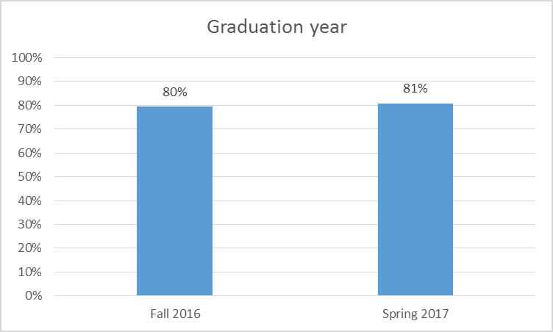

Figure 12 Employment in Jobs Related to Undergraduate Field of Study by Semester of Graduation

Finding a job in one’s undergraduate field of study depended on the major. All (100%) those who majored in Business (Family & Entrepreneurial Management), Business ( Management Information Systems), Hospitality and Tourism Management, Computer Engineering, Social Work, English, Education, Electrical Engineering and Mathematics, secured a first job that was related to their undergraduate field of study. Most alumni (96% - 70%) majoring in, Pharmacy, Computer Science, Business (Accounting), Mechanical Engineering, Civil Engineering, Industrial Engineering, Business (Marketing), Architecture, Interior Architecture, Graphic Design, Nursing, Nutrition, Political Science/International Affairs, Communication Arts and Business (Banking & Finance) reported securing a first job in their undergraduate field of study. This percentage dropped to 69% and below for alumni who majored in Business (International Business), Business (Management), Business (Information and Technology Management), Psychology, Biology, Chemistry, Interior Design and Economics (Figure 13).

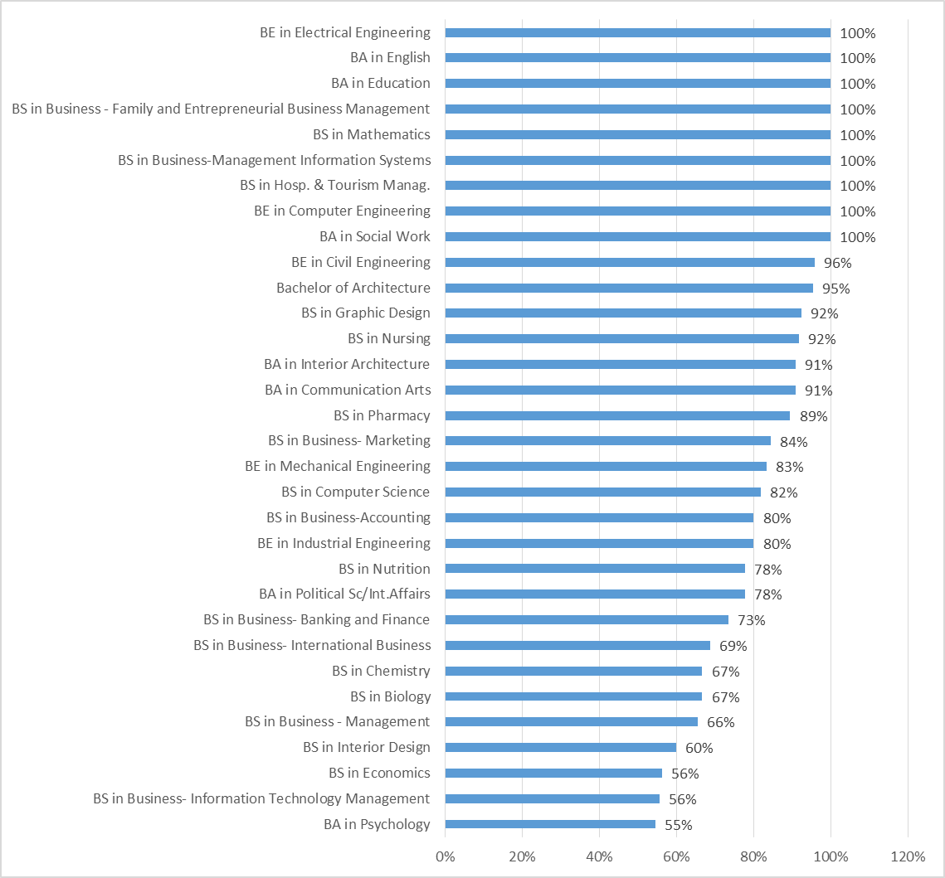

Figure 13 Employment in Jobs Related to Undergraduate Field of Study by Undergraduate Degree

### Location

The vast majority of respondents found their first job in Lebanon (91%) whereas 5% found their first job in the gulf region, 1% in North America, 1% in the Levant and 1% in Africa (Figure 14). With respect to employment in the Gulf region, a significant drop can be noticed when comparing graduates of 2014-2015 (20%) to graduates of 2015-2016 (9%) and graduates of 2016-2017(5%), which could be attributed to the economic and political instability in the region.

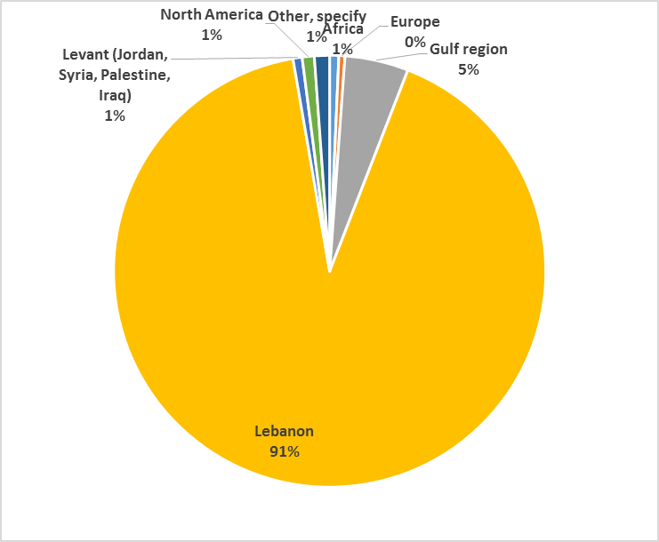

Figure 14 Employment by Job Location

Actual geographic employment sites for first jobs of alumni were aligned to a large extent with preferred geographic employment sites. Around 67% of alumni indicated a preference to stay in Lebanon for their first job whereas 18% did not indicate any geographical preference. The Gulf region was a preferred first job employment site for 10% of alumni, followed by Europe (2%) and Levant (2%). More females (78%) compared to males (57%) were inclined to secure their first employment in Lebanon. The Gulf was a first employment destination for males only (Figure 15)

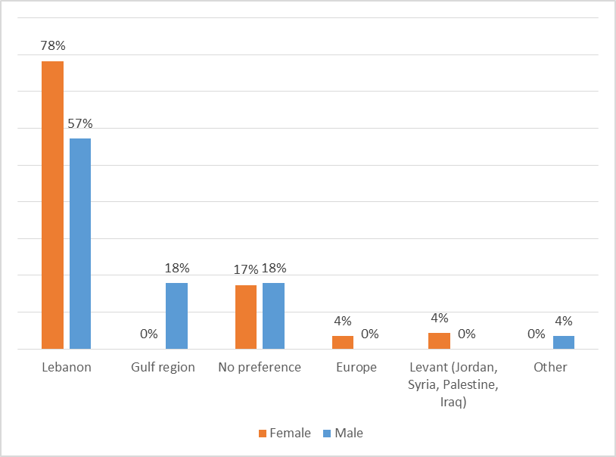

Figure 15 Geographical Preference of First Job Location by Region

In general, however, around 20% of LAU graduates prefer to be employed outside Lebanon (Figure 16).

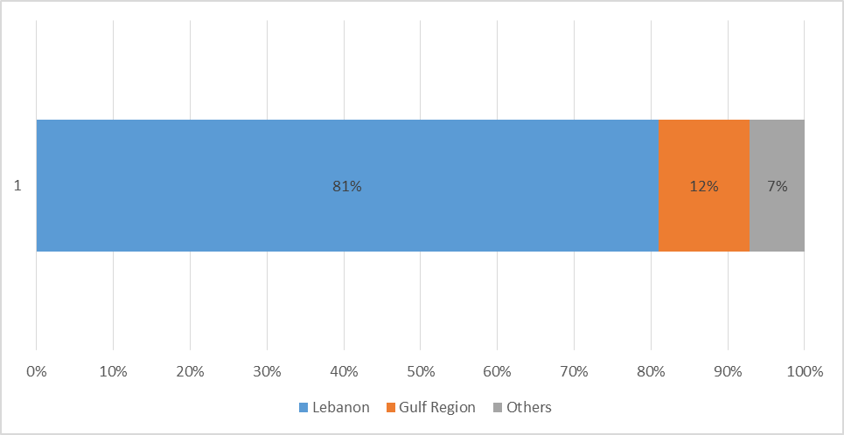

Figure 16 Geographical preference of first job location by region (summary)

All the majors offered by LAU were found to correlate positively with the demands of the Lebanese labor market. All alumni (100%) who graduated from SOP and ARCSON reported being employed in Lebanon. This percentage dropped to 95% of alumni who graduated from SArD and to 93% for those who graduated from SAS and 91% for those who graduated from AKSOB. External market demands varied according to the region. Employment outside Lebanon was found to be highest for graduates of SOE (17%) followed by AKSOB (9%), and SAS (7%) (Figure 17)

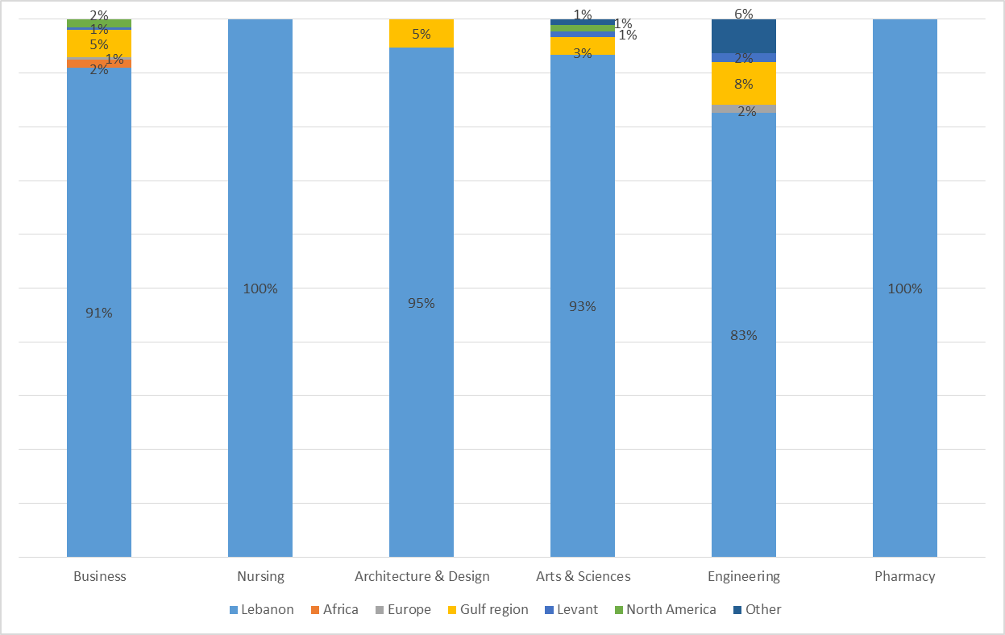

Figure 17 Employment Rates by School and Location

Majors seen to be the most requested by external employers include Business (Banking & Finance, Marketing), Architecture, Communication Arts, Economics, and Engineering (Civil, Computer, Electrical). Employers based in Africa have recruited alumni who majored in Business (Management), Business (Banking & Finance), and Economics. Employers from the Gulf region mainly recruited Business majors (Marketing, International Business and Banking & Finance) along with Engineering (Civil and Electrical) and Architecture majors. As for employers based in North America, they have recruited from the Business (Management, Marketing, and ITM) and Psychology. When it comes to Europe, employers have recruited Business (Banking and Finance_ and Engineering (Civil), and lastly employers in the Levant recruited Communication Arts, Engineering (Computer) and Economics (Figure 18).

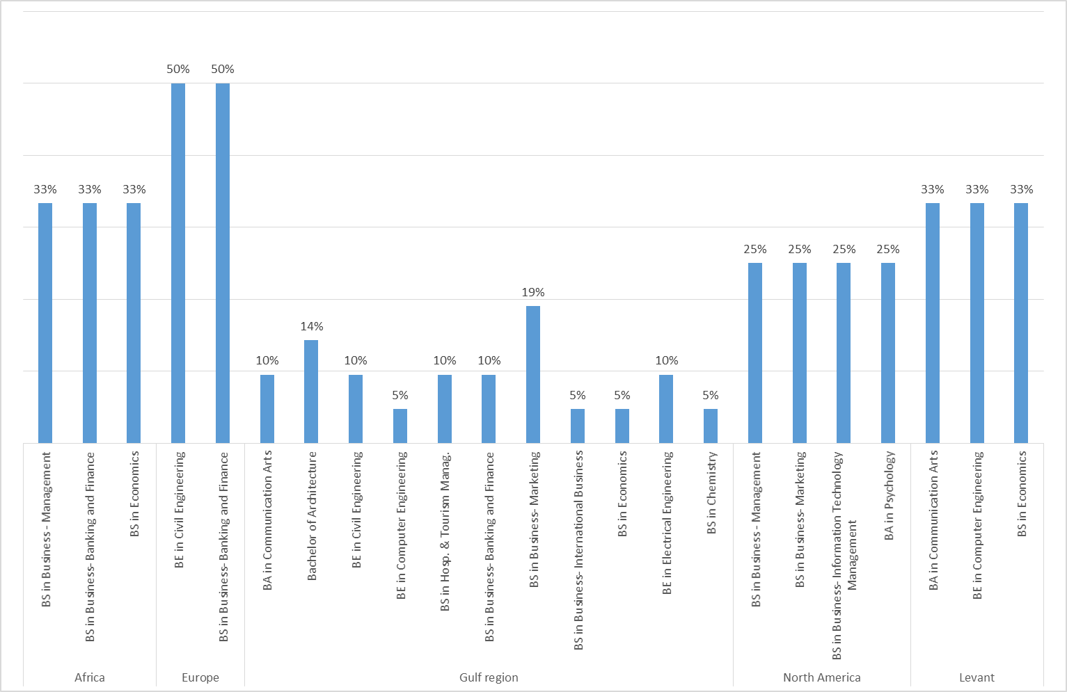

Figure 18 Alumni Employed Abroad by Degree

* As for alumni who were employed in Lebanon, most were based inside the capital Beirut (73%) and an additional 19% were based in the Mount Lebanon Governorate (Figure 19). The percentage of alumni employed in Beirut decreased from 81% for graduates of 2011-2012 to 75% for graduates of 2015-2016 and to 73% for the graduates of 2016-2017. There has been a decrease in LAU graduates employed in Beirut in the last few years which reflects a spread of employment opportunities across the country especially in the governorate of Mount Lebanon. (Figure 20)

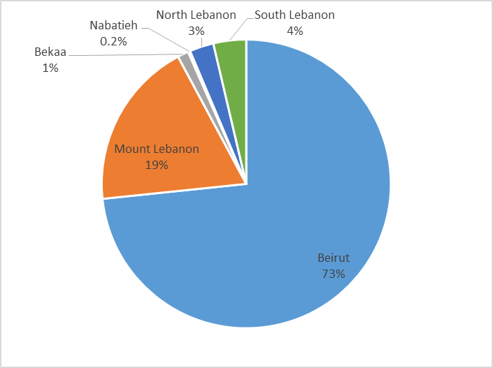

Figure 19 Employment by governorate

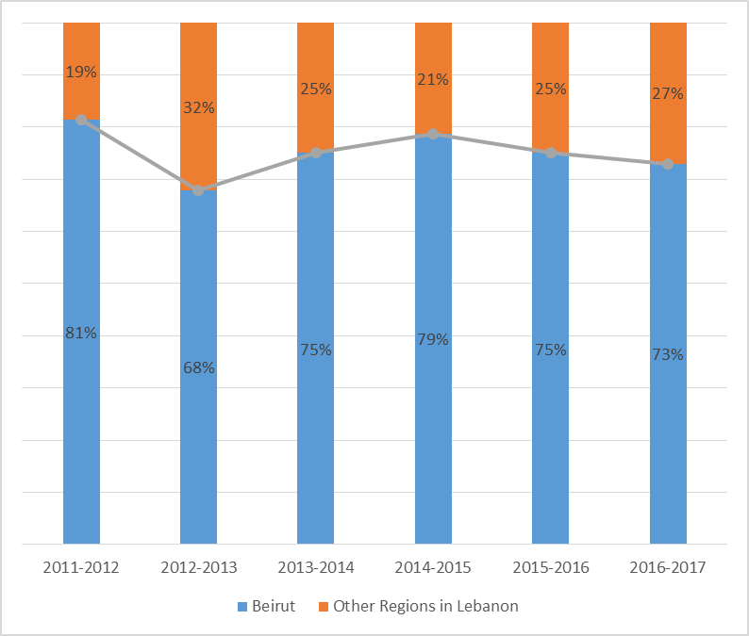

Figure 20 Trends in Employment By Governorate

### Industry

Alumni were asked to provide the industry of the company they were employed in. The “Architecture & Construction” industry employed the most alumni (18%), followed by Non-Governmental Organization (10%), Sales & Distribution of Consumer Products (6%), Health Science/Medical (6%), Finance/Banking (6%), and Education & Training (6%), Science, Technology, Engineering & Mathematics (4%), Marketing, Sales& Services (4%), IT (4%) and Arts, A/V Technology & Communications (4%), among others. (Figure 21).

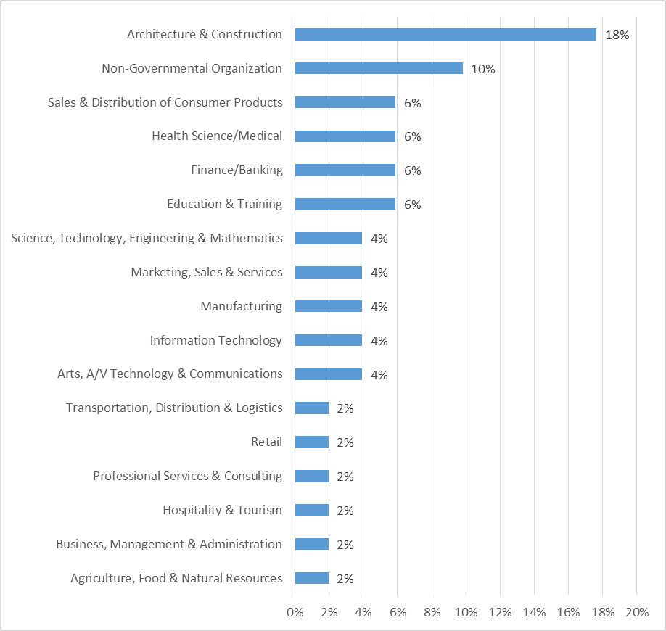

Figure 21 Employment by company industry

### Starting Basic Salary

The average starting basic salary for all alumni respondents amounted to $1,153. The average starting basic salary for males is $1,257 which is higher than that of the average basic salary for females of $1,064 (Figure 22). Comparing to previous years, there was no significant variation for salaries across the years of graduation which indicates the availability of stable starting packages for LAU graduates during the past few years.

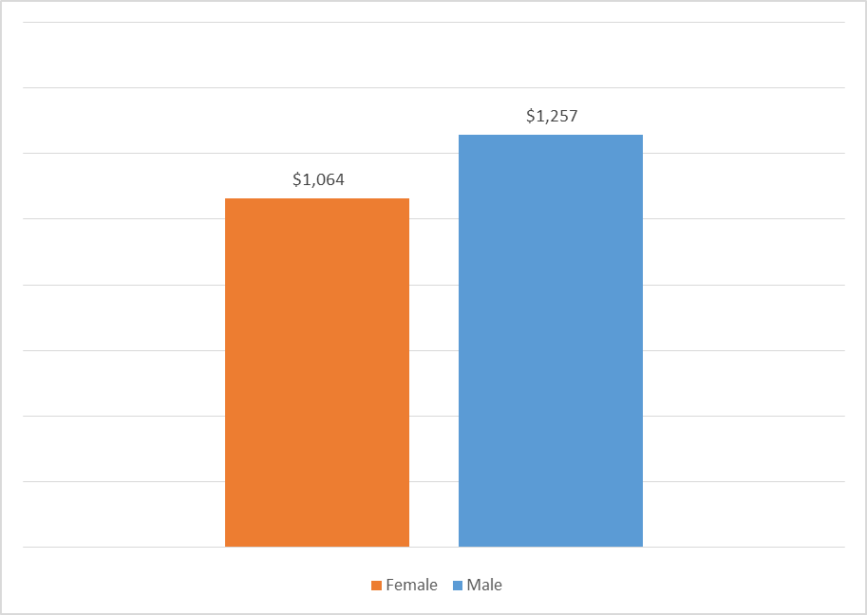

Figure 22 Average Starting Basic Salary by Gender

This observation is reinforced by looking at the starting basic salary brackets. We can notice that the majority of females or 80% of them earn within the low starting salary brackets $700-$1200 versus only 55% of the males. In contrast, when it comes to salaries between $1201- Above $3000, females only constitute 21% versus 45% of the males. For instance, it is worth noting that only 8% of females earn a salary between $1500 and $3000 in comparison to 16% in males. (Figure 23)

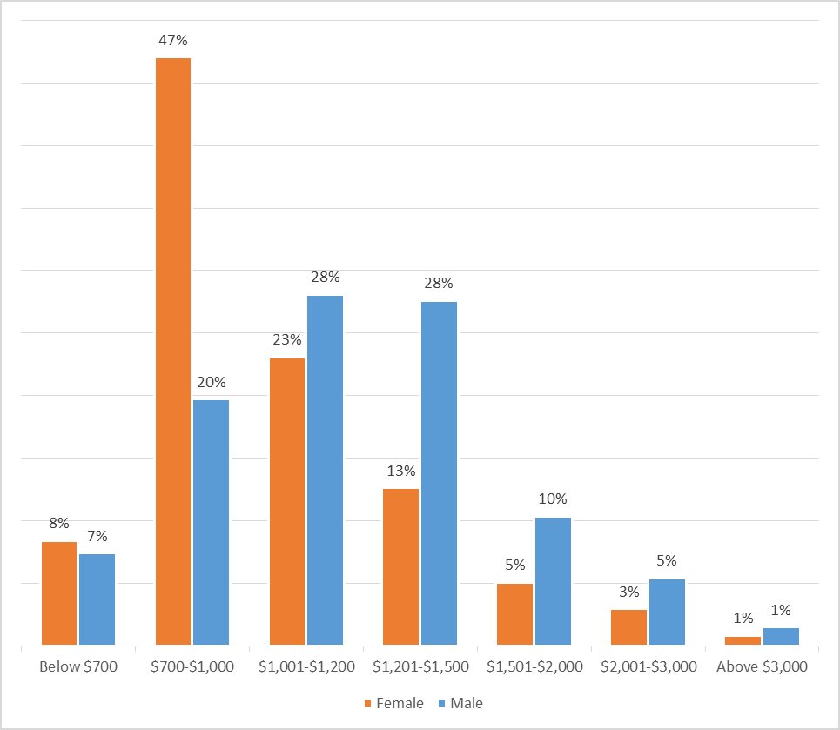

Figure 23 Starting Basic Salary Brackets by Gender

Alumni employed in North America are earning the highest starting basic salaries. On average, they are earning a starting basic salary of $1,963, followed by $1,651 for those employed in Africa, $1,598 for those in the Gulf Region and $1,426 for those in Europe. Employees in Lebanon and the Levant are earning the lowest starting basic salary of $1100 (Figure 24).

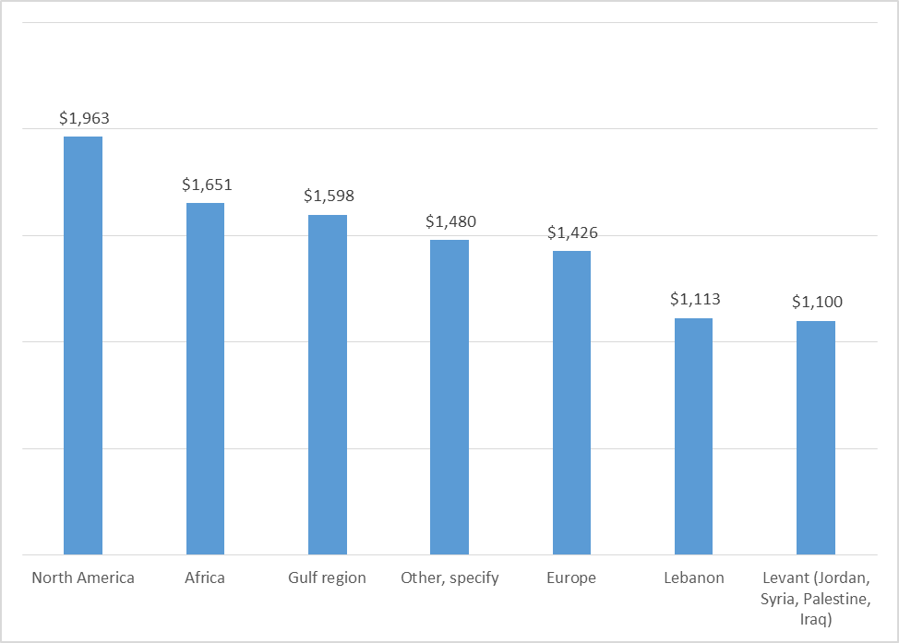

Figure 24 Average Starting Basic Salary by Region

Respondents who majored in Multimedia Journalism, Fashion Design, Pharmacy, Engineering (Mechanical, Computer, Industrial, Electrical, and Civil), Business (Family and Entrepreneurial Business Management, Marketing, International Business), and Architecture earned the highest starting basic salaries. On the other hand, respondents who majored in Social Work, Business (Management Information Systems), Nutrition and Dietetics (Coordinated Program), Interior Design, Mathematics, Biology, Nutrition, Interior Architecture, Education and English earned the lowest starting basic salaries. (Figure 25)

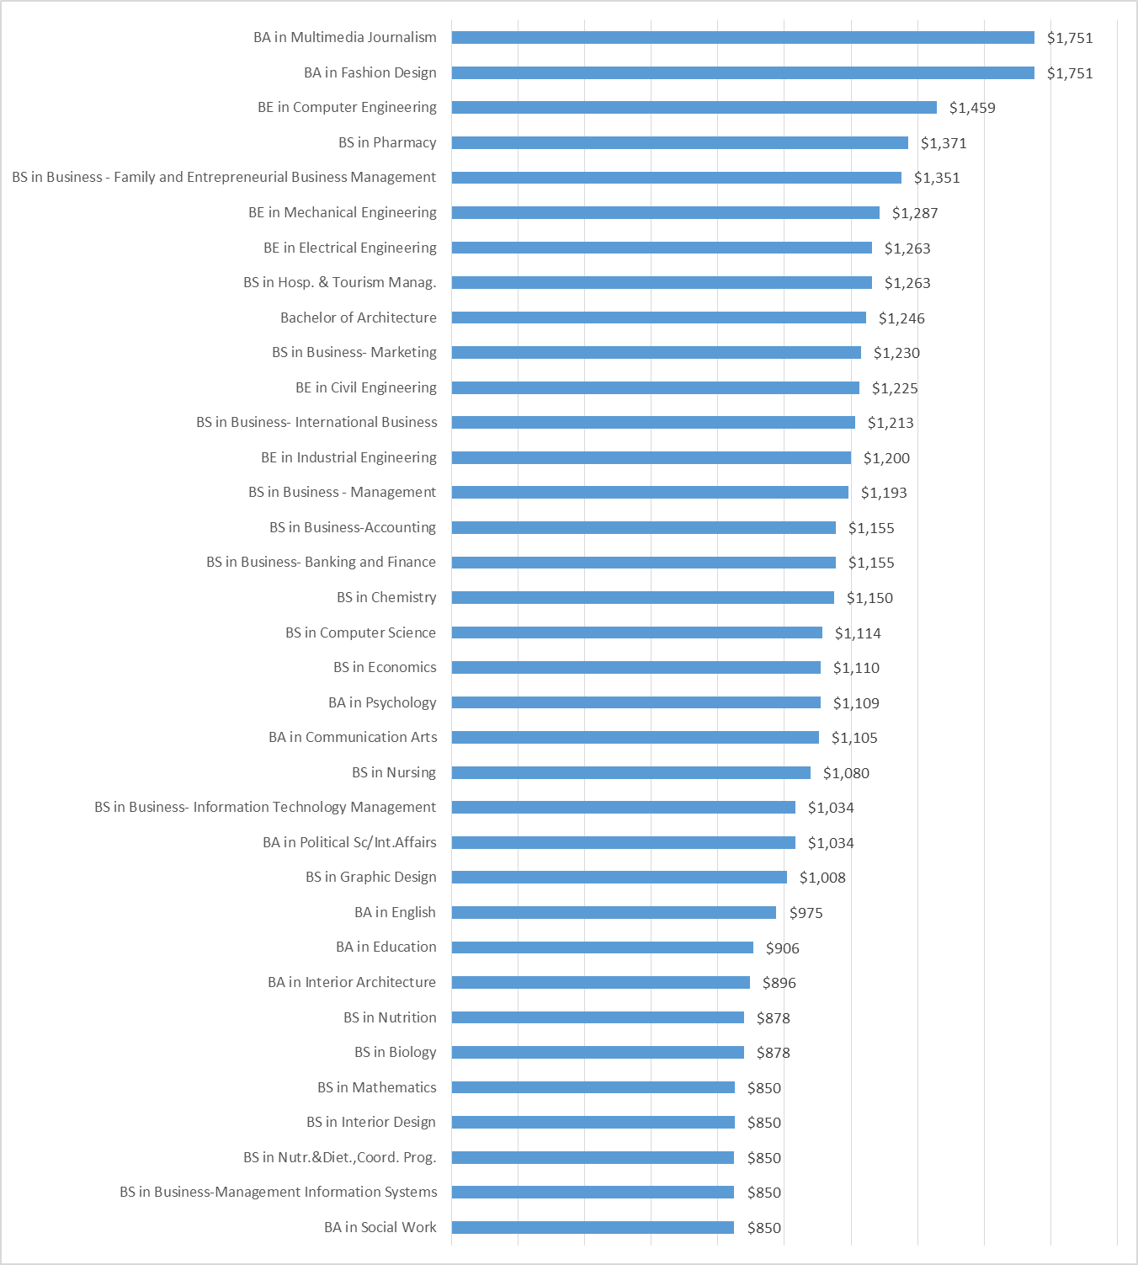

Figure 25 Average Starting Basic Salary by Degree

When comparing average starting basic salaries across industries, alumni employed in the Arts, A/V Technology & Communication earn the highest salaries ($2,025) followed by alumni employed in Business, Management & Administration ($1,351), Sales & Distribution of Consumer Products($1,317), Science, Technology, Engineering & Mathematics($1,226), Information Technology ($1,226) and Architecture & construction($1,189). (Figure 26)

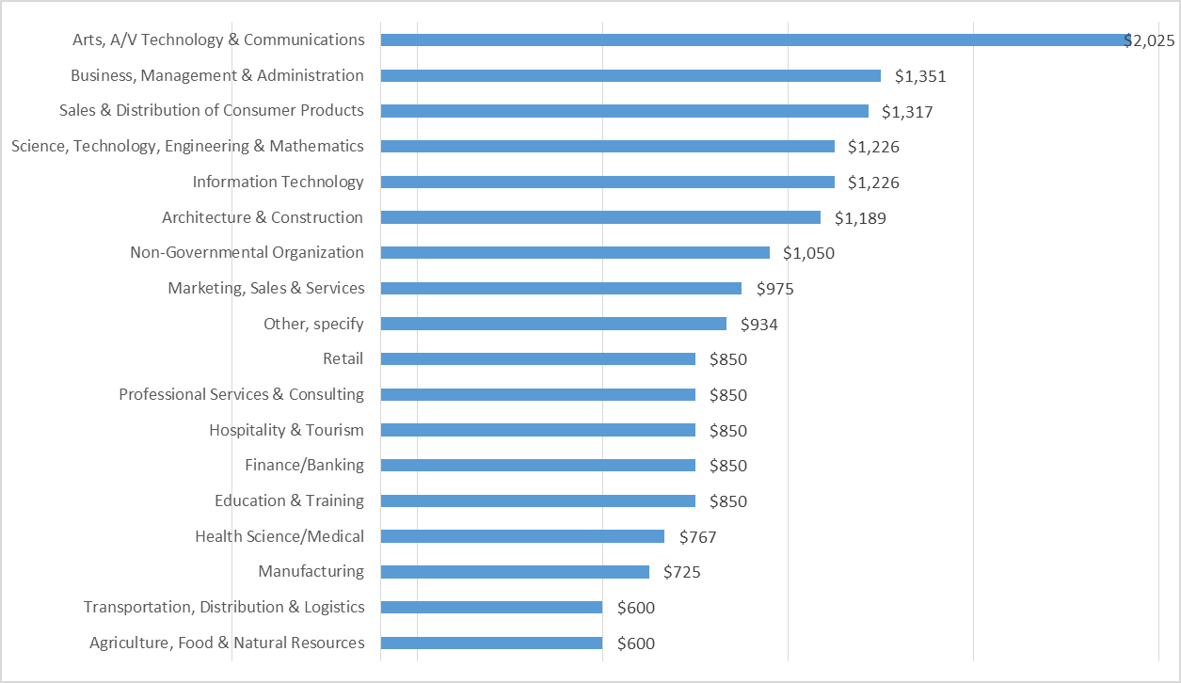

Figure 26 Average Starting Basic Salary by Industry

Earnings varied based on time needed to secure intial employment. Alumni who were able to secure a job before graduation earned an average starting basic salary of $1,232. The average dropped to $1,175 for those who secured a job within less than three months after graduation but steadily decreased to $1,130 for those who secured the job in 3-6 months. The average starting basic salary drops to $1,015 for those who secured their first job within 6 – 12 months after graduation. This is possibly due to alumni who did not wait much longer and thereby accepted lower salary ranges. However, the average basic salary jumped to $1,263 for those who secured the job within 1-2 years of graduation. (Figure 27).

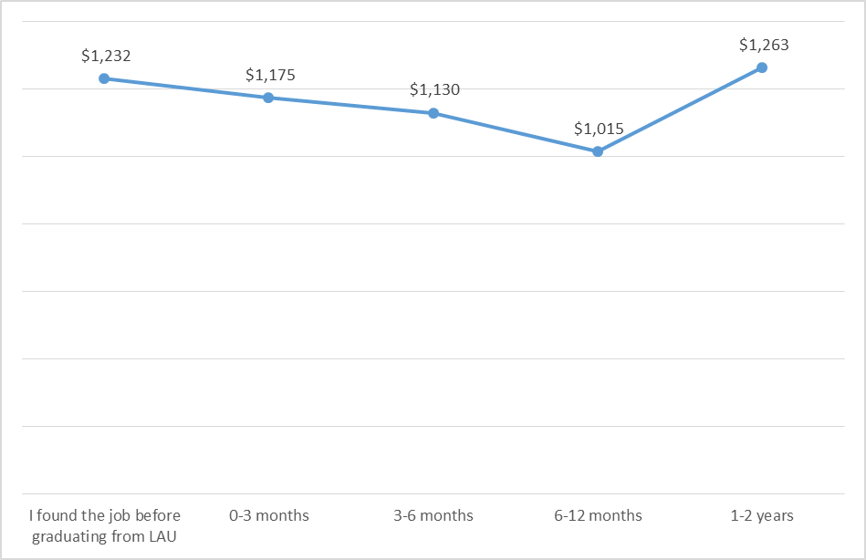

Figure 27 Average Starting Basic Salary with respect to Time from Graduation

### Other Company Characteristics

The vast majority of alumni (96%) reported being employed in a private company (Figure 28). In addition, 63% reported having worked in international or regional companies (Figure 29).

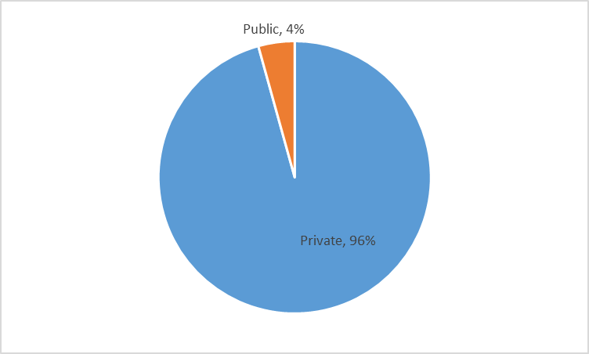

Figure 28 Company Type

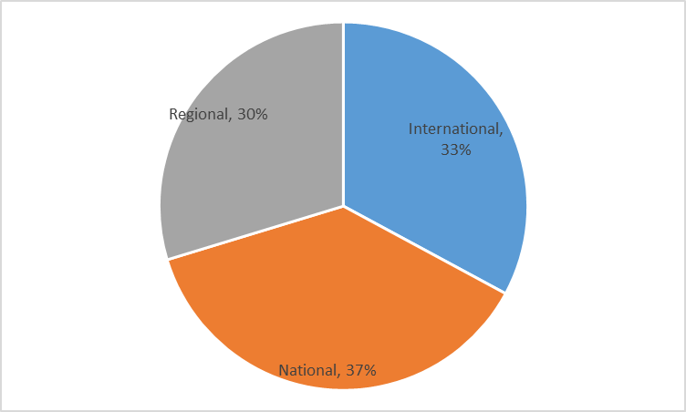

Figure 29 Company classification

## University Experience & Skills Acquired

### Internship Experience

When it comes to respondents’ experience prior to graduating, 72% reported having taken an internship while completing their undergraduate studies at LAU. Out of the alumni who had an internship experience, 25% were offered a full-time job afterwards in the same company. Those who majored in (1) Fashion Design, (2) Biology, (3) Hospitality & Tourism Management and (4) Industrial Engineering were in the majority offered a full-time job after completing their internship (Figure 30).

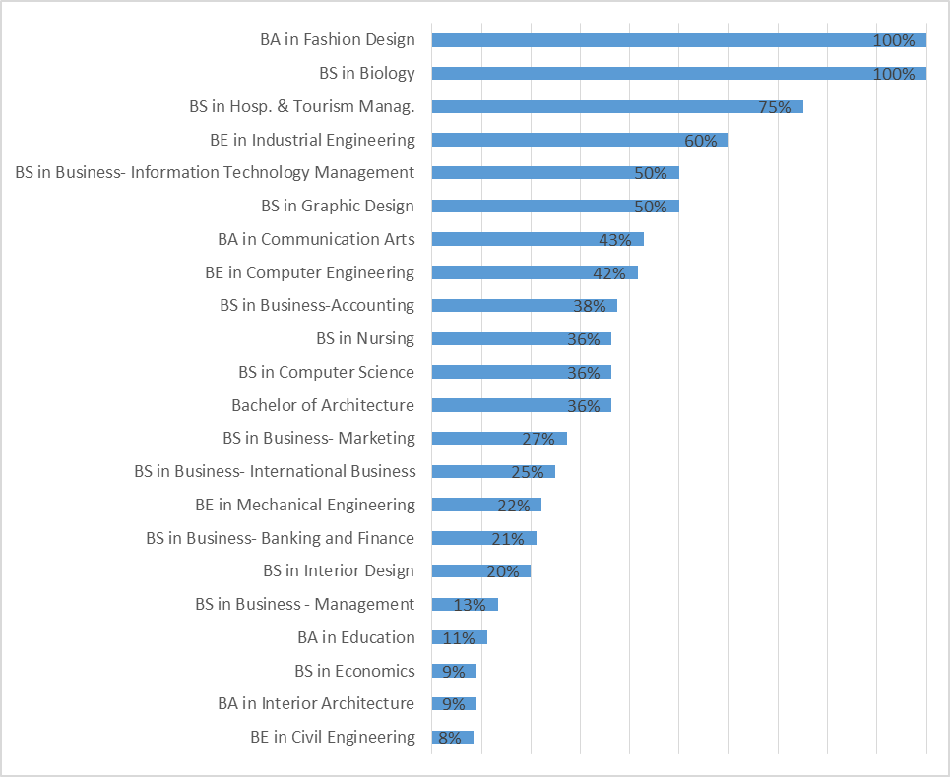

Figure 30 Alumni who were Offered a Full-Time Job After Completion of Internship by Degree

### Satisfaction with University Experience

When asked about the university they would chose if they had to start their undergraduate studies over again, 91% of alumni responded that they would pursue their studies at LAU. Of those, 62% would pursue the same degree they have earned whereas 29% would pursue another degree at LAU. Only 9% would choose a different institution (Figure 31). Female respondents seem to be slightly more satisfied than their male counterparts with their LAU experience as 93% would pursue their studies at LAU should they start again compared to 89% of males who would do the same.

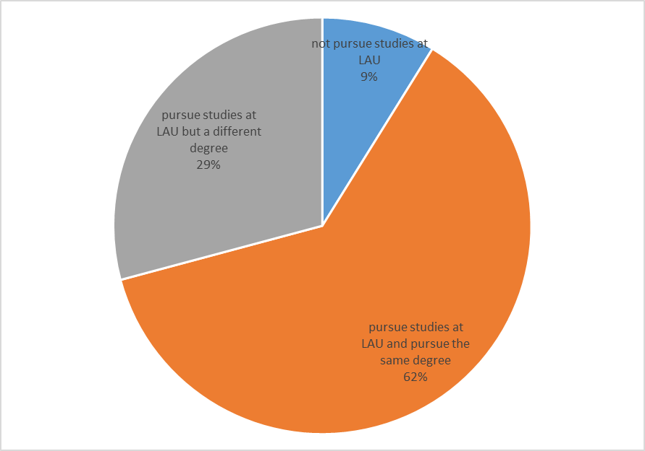

Figure 31 University choice of alumni were they to start again

Alumni who were mostly satisfied with their experience in their programs majored in Chemistry, Bioinformatics and Fine Arts as all respondents from those (100%) would pursue their studies at LAU and pursue the same degree were they to start again. A majority (67% and above) of alumni who majored in Pharmacy, Biology, English, Nutrition, Computer Science, Business (Banking & Finance, Marketing), Industrial Engineering, Computer Engineering, Mechanical Engineering, Political Science/International affairs, Education and Economics and also would pursue the same degree at LAU (Figure 32).

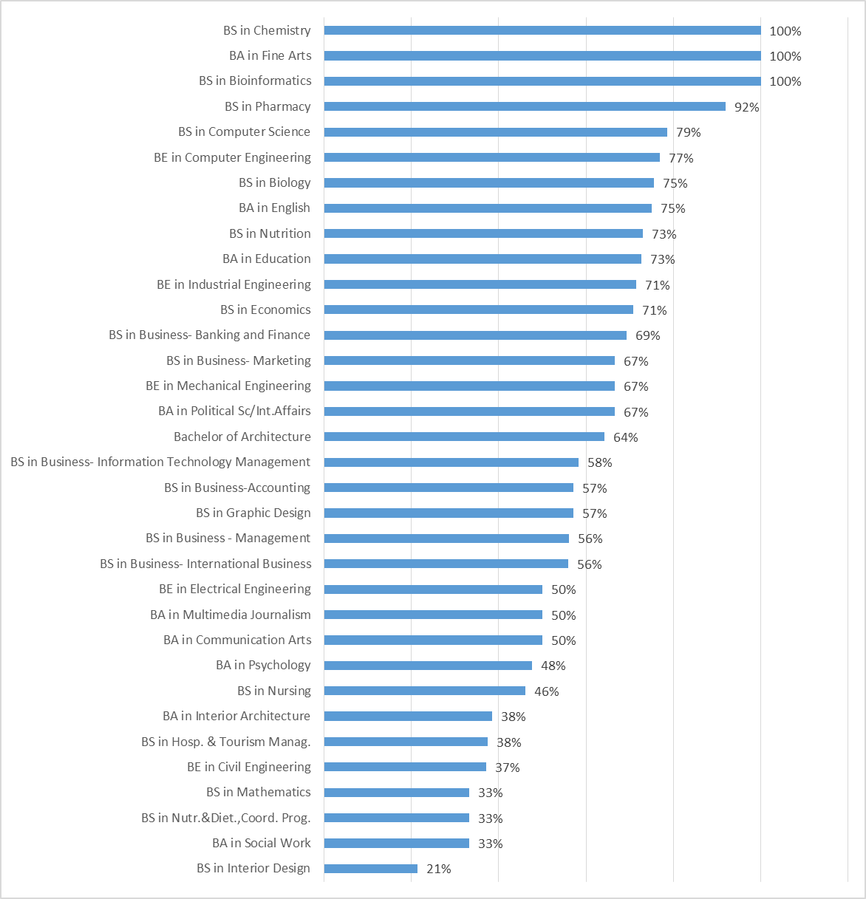

Figure 32 alumni expression an interest to pursue same degree at lau should they start again by degree

### Job Preparation

Over half (51%) of respondents believed that they were sufficiently prepared to obtain their first job. Females seem to be as confident as males with respect to this aspect (Figure 33). All alumni (100%) who majored in Political Science/International Affairs, Multimedia Journalism and Hospitality& Tourism Management shared the view that they were sufficiently prepared to obtain their first job. In addition, a majority of alumni (67% - 88%) who majored in: Nutrition, Graphic Design, Computer Engineering, Mechanical Engineering, Education and Biology (Figure 34) were also satisfied by their level of preparation for the job.

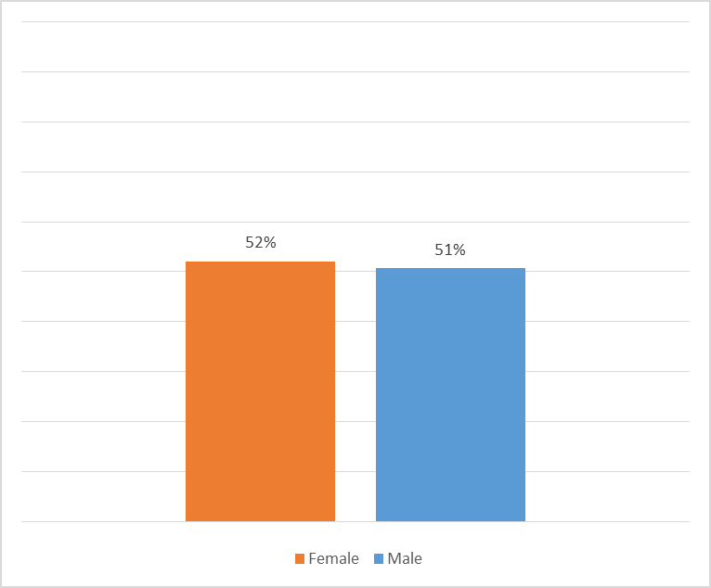

Figure 33 Alumni who Believed they were Sufficiently Prepared to Obtain First Job by Gender

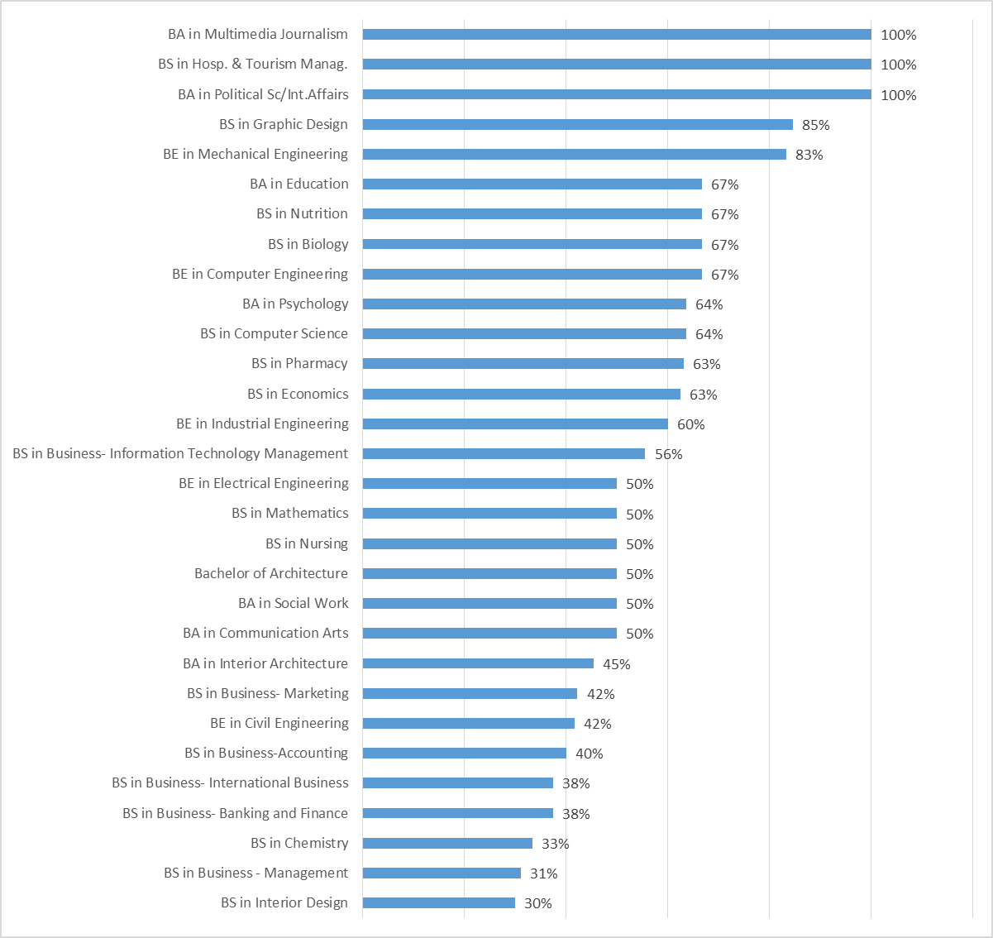

Figure 34 Alumni who Believed they were Sufficiently Prepared to Obtain First Job by Degree

Alumni who had at least one employment experience were asked to compare their job preparation they had received at LAU to the preparation received by other graduates from similar programs they had encountered at work. In total, 94% of alumni believed that the preparation they received is the same or better than that received by their peers from other universities. (Figure 35).

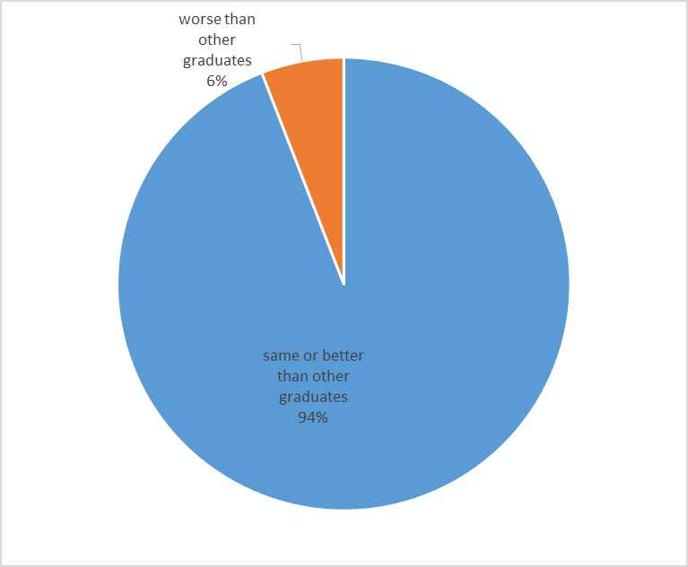

Figure 35 Comparison of Job Preparation Received by LAU Alumni to Other Graduates

### Skills acquired

When asked about the extent to which their LAU education contributed to the acquisition of major skills, 63% or more of alumni believed that their LAU education had a significant contribution (either “major” or “significant”) to their acquisition of the following: (1) functioning as a team member, (2) ability to think critically and approach new problems with an open and analytical mind (3) developing oral communication skills, (4) developing written communication skills and (5) instilling commitment for life-long learning. An average of 24% believed that their LAU education contributed moderately to their acquisition of the previously mentioned skills (Figure 36). In addition, an average of 33% believed that their LAU education had moderate contribution to them (1) becoming aware of ethical issues inherent in their discipline and (2) acquiring theoretical skills to pursue a career path or post bachelor education related to their major field of study.

On the other hand, around 21% found that their LAU education had a minimal contribution (“minor” or “no contribution”) to their acquisition of these skills: (1) developing management/leadership capacities, (2), becoming aware of legal and social issues inherent in their discipline, (3) using effectively modern technology and (4) acquiring technical skills to pursue a career path or post bachelor education related to their major field of study.

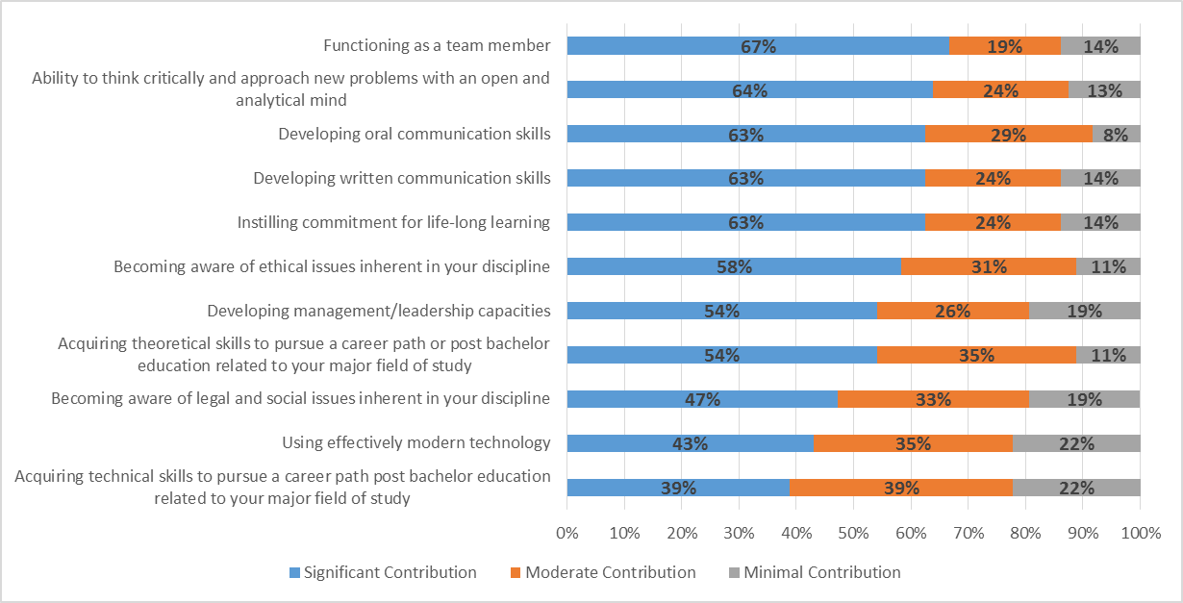

Figure 36 LAU’s contribution to acquisition of skills by alumni